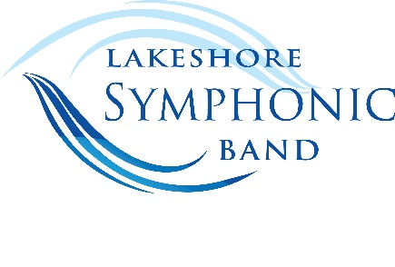
Proudly sponsored by the
2023 YOUNG ARTIST
COMPETITION APPLICATION
Performer’s Name ____________________________________________________________________________
Home Address ______________________________________________________________________________
City, State, Zip ______________________________________________________________________________
Contact data Home/Cell phone _________________________ E-mail __________________________________
High School __________________________________ Band Director __________________________________
Instrument___________________________________________________________________________________
Title of Audition Piece __________________________________________________________________________
Composer / Arranger __________________________________________________________________________
Publisher of Audition Piece _________________________________________________________________________
Note: A band or chamber wind ensemble accompaniment for your selection
must be available for purchase or loan – no rentals allowed.
If you are uncertain, check with your band director, private music teacher or e-mail: pczar@netzero.net

I recommend this student for the Lakeshore Symphonic Band’s 2020 Young Artist Competition.
___________________________________________________________________________________________
Signature of band director or private teacher
*******************************************************************************************
I give permission for my son/daughter to enter the 2020 Lakeshore Symphonic Band’s Young Artist Competition.
___________________________________________________________________________________________ Signature of parent or guardian
*******************************************************************************************
I give permission for my picture to appear in advertising for the 2019 Lakeshore Symphonic Band’s Young Artist Competition, and for my audition/performance to be recorded.
___________________________________________________________________________________________
Signature of Applicant
Completed application and entry fee of $10.00 must be received by: Friday, March 10, 2023.
Audition Date: Tuesday March 21, 2023
Enclose a check for $10.00 made out to Lakeshore Symphonic Band and mail application to:
Patricia Czarnecki, 956 Algoma Dr., Port Washington, WI, 53074
OR you may submit payment via PayPal through our website: www.lakeshoresymphonicband.org

